dress__________________________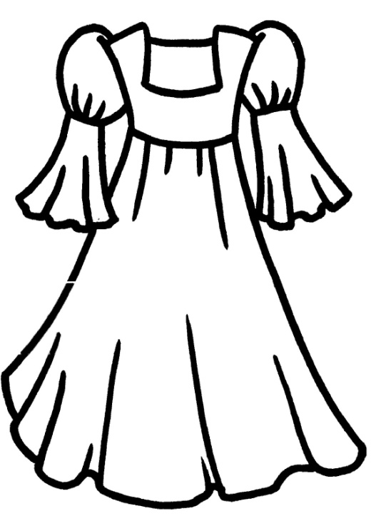

hat____________________________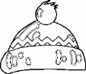

sandals________________________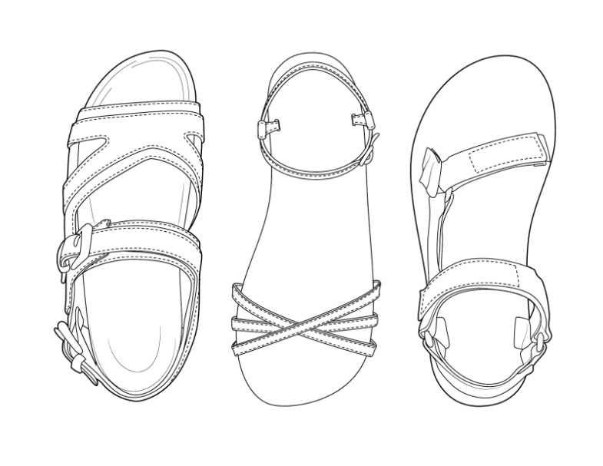

jeans___________________________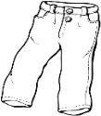

T-shirt_________________________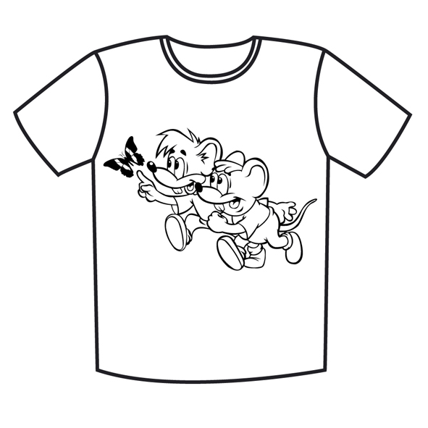

socks__________________________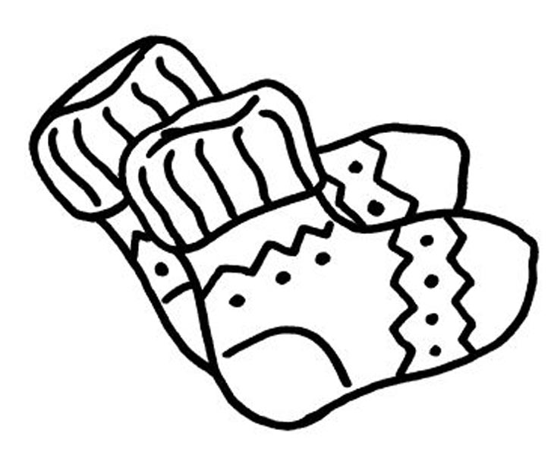

mittens________________________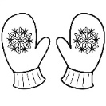

shorts_________________________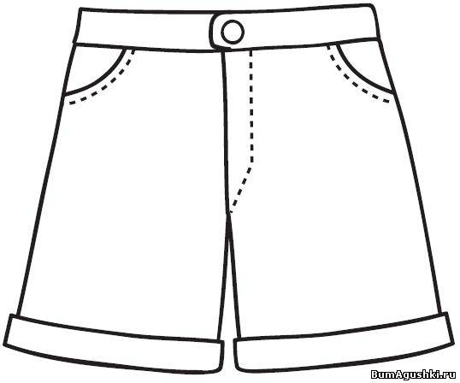

jacket_____________ _________________________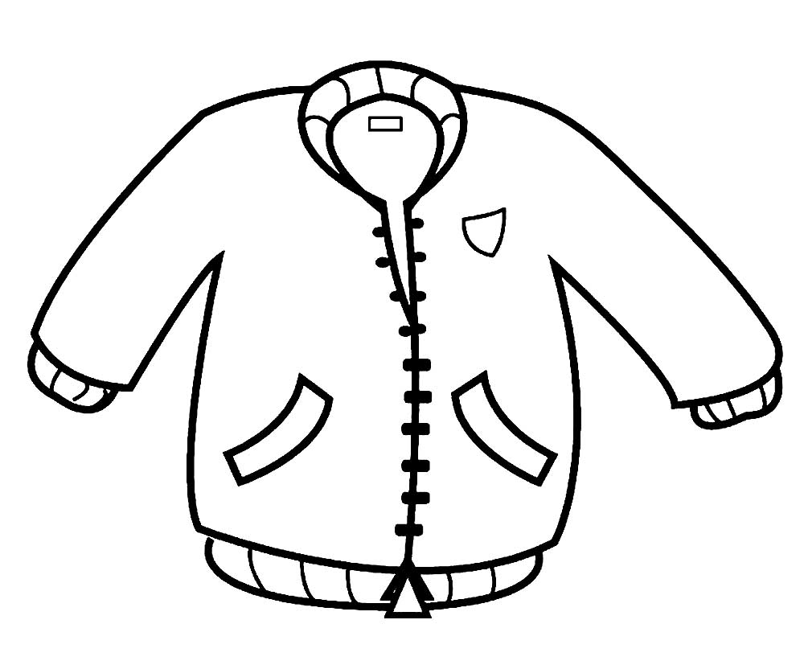

pants__________________________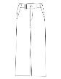

dress__________________________

hat____________________________

sandals________________________

jeans___________________________

T-shirt_________________________

socks__________________________

mittens________________________

shorts_________________________

jacket_____________ _________________________

pants__________________________