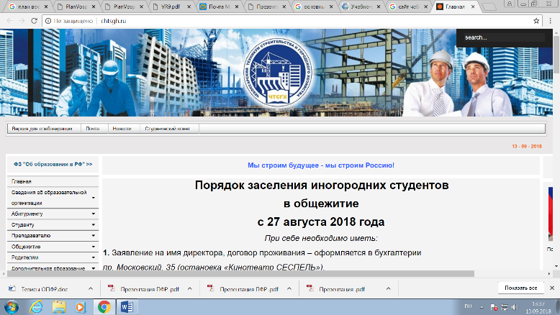

http://www.chtsgh.ru/

http://vk.com/club45635519

https://twitter.com/CHTSGH_21

https://www.facebook.com/profile.php?id=100028572334242
https://www.instagram.com/studsovet_chtsgh/?utm_source=ig_profile_share&igshid=150w50aqi75m1
https://youtu.be/hCLBZGXf6As

